Date:

Student Name 1:

Student Name 2:

Student Name 3:

Student Name 4:

**ARTIFICIAL INTELLIGENCE AND THE ROLE OF AUTOMATION**

With a partner or in a group, conduct a debate adopting the two positions outlined below. Once you have chosen your positions take some time to prepare your debate.

**Situation**: *The year is 2025. You are at a summit to decide what laws your country will put in place regarding research into Artificial Intelligence. Strong AI is decades away, but even normal AI has begun to take jobs from human workers. You and your partner must discuss your views on AI research and come to a compromise on the future laws for your country.*

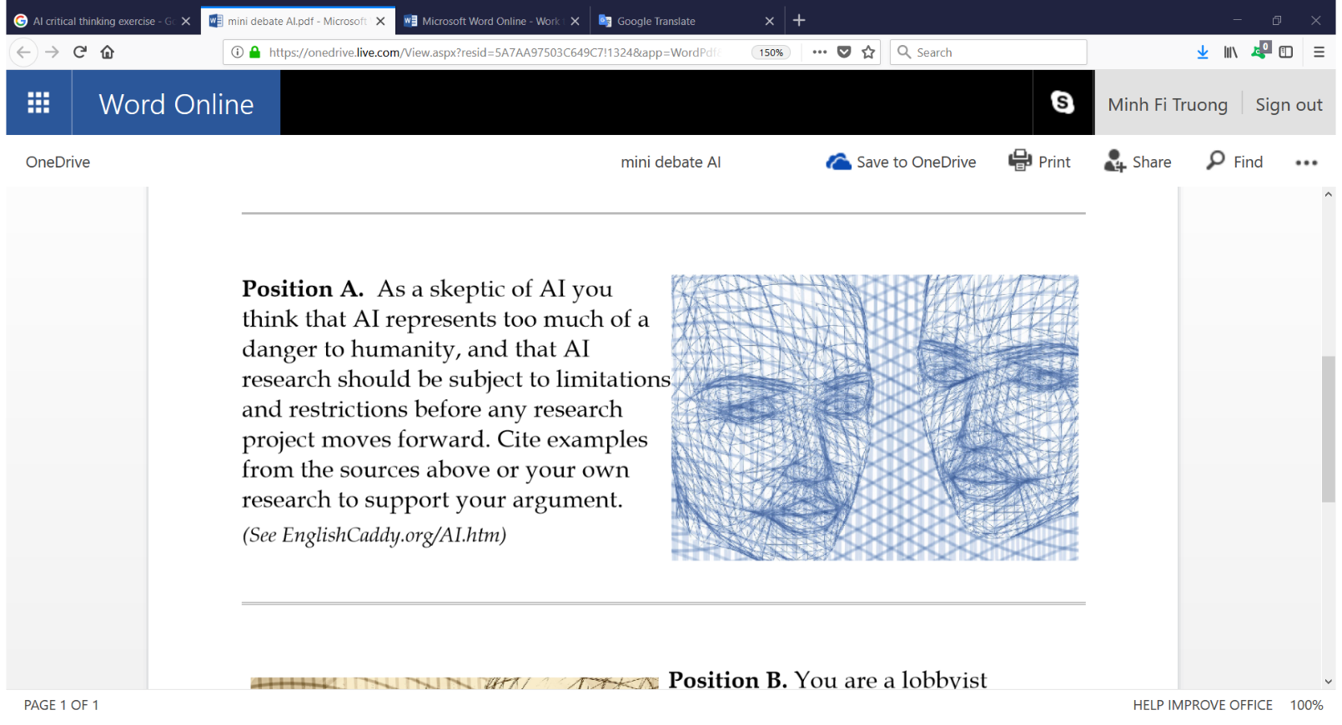**Position A**: As a skeptic of AI you think that AI represents too much of a danger to humanity, and that AI research should be subject to limitations and restrictions before any research project moves forward. Cite examples from Internet or your own research to support your argument.

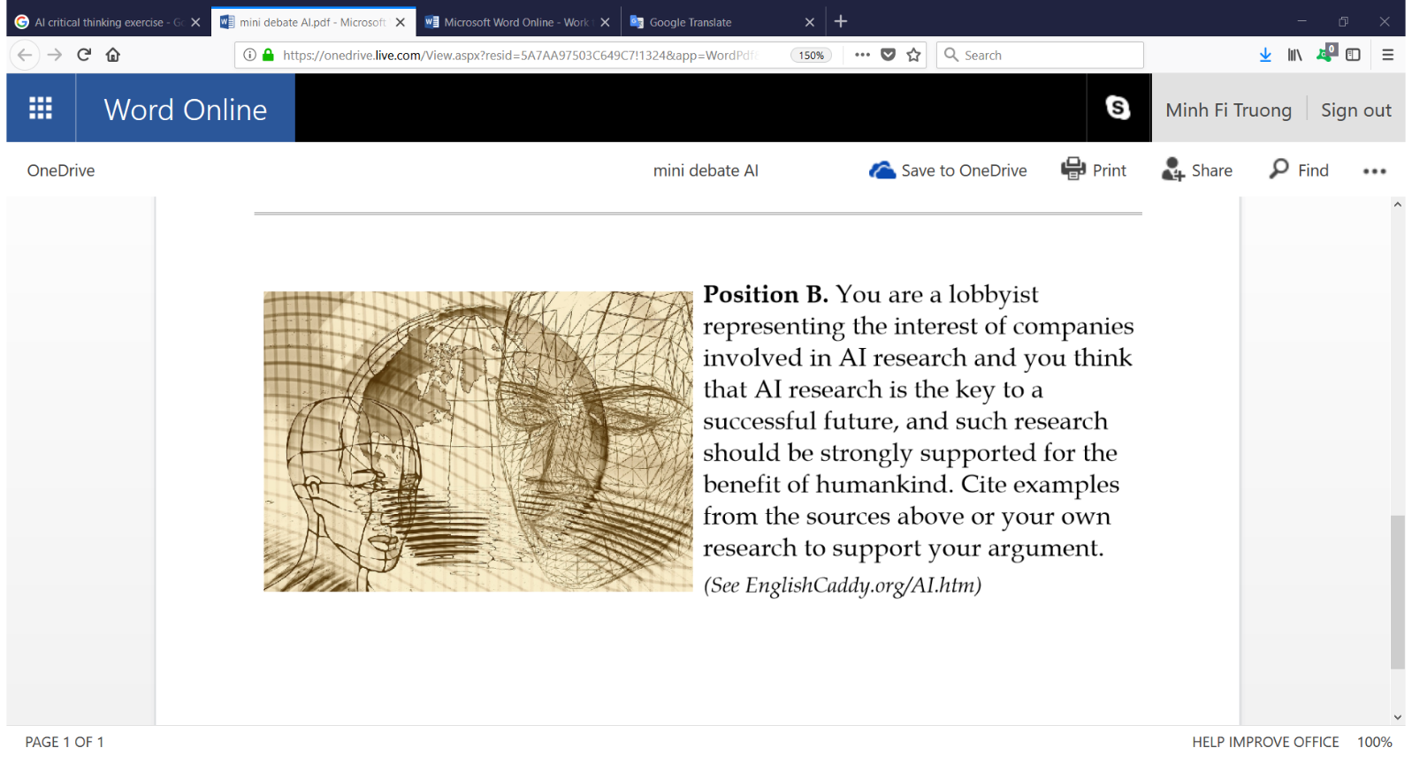**Position B**: You are a lobbyist representing the interest of companies involved in AI research and you think that AI research is the key to a successful future, and such research should be strongly supported for the benefit of humankind. Cite examples from Internet or your own research to support your argument.